7.3.7 Editors - 3D View - Sidebar - Tool Tab - Grease Pencil Object - Sculpt Mode
Sculpt Mode 1
Sculpt Mode - Brushes Panel 1
Brush browser 1
Sculpt Mode - Brush Settings Panel 2
Radius 2
Strength 2
Weight 2
Use Falloff 2
Add / Subtract 2
Clockwise/Counter Clockwise 2
Pinch / Inflate 2
Sculpt Mode - Brush Settings Panel - Sculpt Strokes Subpanel 2
Affect Position, Strength, etc. 2
Sculpt Mode - Brush Settings Panel - Cursor Subpanel 2
Show Brush 3
Color 3
Grease Pencil - Weight Paint Mode 3
Weight Paint Mode - Brushes Panel 3
Brush browser 3
Weight Paint Mode - Brush Settings Panel 3
Radius 3
Strength 3
Weight 3
Use Falloff 4
Weight Paint Mode - Brush Settings Panel - Cursor Subpanel 4
Show Brush 4
Color 4

Sculpt Mode

In Sculpt mode you can sculpt the grease pencil strokes.

Sculpt Mode - Brushes Panel

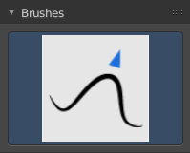
Brush browser
Here you can pick a pencil, and see what pencil is active.
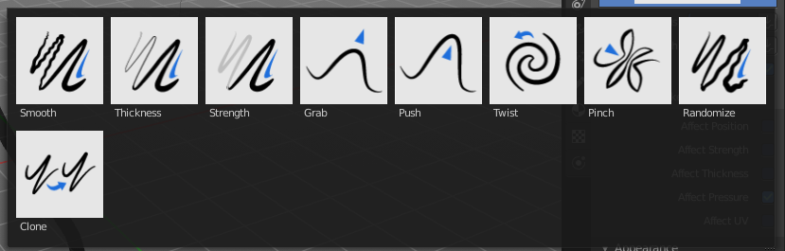

Sculpt Mode - Brush Settings Panel

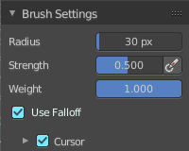
Radius
The radius of the brush.

Strength
The strength of the brush.

Weight
The target weight. Everything below gets added towards this value. Everything above gets subtracted from this value. Usually you work with the maximum value of 1.

Use Falloff
Use Falloff for the brush.

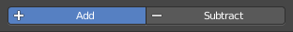
Add / Subtract
Thickness and Strength brush. If this brush should add or subtract to the sculpt surface.

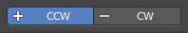
Clockwise/Counter Clockwise
Twist brush. If the twist goes clockwise or counter clockwise.


Pinch / Inflate
Pinch brush. If the brush should pinch or inflate.

Sculpt Mode - Brush Settings Panel - Sculpt Strokes Subpanel
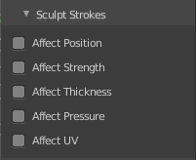

Affect Position, Strength, etc.
Make the strokes affect the listed items too.

Sculpt Mode - Brush Settings Panel - Cursor Subpanel
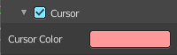

Show Brush
Show the brush icon when painting.

Color
The brush icon color.

Grease Pencil - Weight Paint Mode

In Weight Paint Mode you can weight paint your strokes.

Weight Paint Mode - Brushes Panel

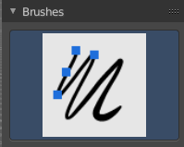
Brush browser
Here you can pick a pencil, and see what pencil is active. There is just one pencil available for weightpainting.
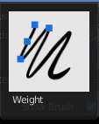

Weight Paint Mode - Brush Settings Panel

Radius
The radius of the brush.

Strength
The strength of the brush.

Weight
The target weight. Everything below gets added towards this value. Everything above gets subtracted from this value. Usually you work with the maximum value of 1.

Use Falloff
Use Falloff for the brush.

Weight Paint Mode - Brush Settings Panel - Cursor Subpanel

Show Brush
Show the brush icon when painting.

Color
The brush icon color.

